Client | [Customer Name will be written here]
Project Name | [Project Name will be written here]

Table of Contents
1 Document Overview 4
1.1 Scope & Purpose 4
1.2 Version Numbers & Standards 4
1.3 Audience 4
1.4 Document Structure and Special Conventions 4
1.5 Definitions, Symbols and Abbreviations 5
1.5.1 Definitions & Terminology 5
1.5.2 Abbreviations 5
1.6 References 6
2 Assumptions 7
3 Overall Requirements Description 8
3.1 Business Requirements 8
3.2 User Characteristics 8
3.3 Postponed/Rejected Requirements 9
4 Functional Requirements 10
4.1 Functionality 10
5 End to End Use Cases 11
5.1 Use Cases Overview 11
5.1 Use Case Realization 11
5.1.1 UC-001: Use New Introduced “Contract Inquiries” page 11
6 Logical Data Model and Persistence Requirements 14
6.1 Main Entities 14
6.2 Special Persistence Requirements 14
7 Interface & Environment Requirements 14
7.1 External/Public Interfaces 14
7.2 User/GUI Interfaces 14
7.2.1 Screen 1 15
7.3 Command Line Interfaces 15
7.4 File-Based Interfaces 15
7.5 Bulk Interfaces 15
8 Non-Functional Requirements 16
9 Solution Sketch and Preliminary Architecture 16
9.1 Prerequisites, Assumptions and Restrictions 16
9.2 Solution Sketch 16
9.2.1 Database Domain 17
9.2.2 System/Application Domain-1 17
9.2.3 System/Application Domain-2 17
9.3 High-Level Processing Logic 17
10 Works, Deliverables and Impacted Areas 18
10.1 Customization Development Works for AS-IS Components 18
10.2 New Development Works 18
10.3 Integration and Configuration Works 19
10.4 Database and Migration Works 19
10.5 Operational & Documentation Works 20
10.6 Other Works 20
Appendix 21
Document Control 21

Document Overview

Scope & Purpose
The scope of this document is to provide a mutually agreed baseline between [CLIENT NAME] and i2i Systems with regards to the client requirements from several viewpoints (functional, operational, use case etc.). Additionally the document also aims to provide an introductory architectural blueprint inline with the requirements.

Version Numbers & Standards

This Specification has been produced by the i2i Systems (i2i) following 3GPP specifications alike versioning scheme and follows the recommendations of “IEEE Std 830-1998, IEEE Recommended Practice for Software Requirements Specifications” standard.

The contents of the present document are subject to continuing work and may be changed by i2i. Should the i2i modify the contents of the present document, it will be re-released with an identifying change of release date and an increase in version number as follows:

Version x.y.z
where:
x the first digit:
1 presented for information;
2 presented for approval;
3 or greater indicates approved document under change control.
y the second digit is incremented for all changes of substance, i.e. technical enhancements, corrections, updates, etc.
z the third digit is incremented when editorial only changes have been incorporated in the document.

Audience
The document may be read by the below audience;
- Business Users
- Business/System Analysts
- Solution/System Architects
- Project Managers
- Quality Assurance Experts

Document Structure and Special Conventions
If the document is complex and specific sections apply to specific reader profile, a brief description of vital sections contained in the document shall be provided.
Such as;

Section X: Explains the details related to xyz providing diagrams. This section shall be read by Business Analysts
Section Y: Explains the details related to wqv from system perspective. This section shall be read by Solution Architects
Etc.

Definitions, Symbols and Abbreviations

Definitions & Terminology

This section provides a common list of definitions considering the Turkish/English terminology.
Turkish | Entity Name | Description
Bayi Yönetimi | Dealer Management | Refers to all customer specific dealer management tasks such as Dealer Activation, Takeover etc.
Bayi Yönetimi – Başvuru | Dealer Application | An application form is filled for the actual activation/ official registration of a dealer. Dealer Application triggers back-end workflow process that considers client specific business rules and approval mechanisms.

Abbreviations

TERM | DESCRIPTION
API | Application Programming Interface
ASN.1 | Abstract Syntax Notation 1. An abstract syntax notation, which is used to describe data and data structure.
BGW | Billing Gateway
BRS | Business Requirements Specification
BSS | Business Support System
CDR | Call Data Record – Records in files generated by external network nodes such as MSC, SDP etc.
DWH | Data Ware House
EDIFACT | Electronic Data Interchange For Administration, Commerce and Transport. EDIFACT indicates a format
EIR | Equipment Identity Register
FMS | Fraud Management System
GUI | Graphical User Interface
HTML | Hyper Text Markup Language.
HTTP | Hyper Text Transfer Protocol. Simple stateless protocol used throughout the internet.
IVR | Interactive Voice Response System
Java | An object orientated programming language which is portable between platforms.
MML | Man Machine Language, specifies the command format API of the HLR
OSS | Operations Support System
SAS | System Architectural Specification
SOAP | Simple Object Access Protocol  SOAP is a simple XML-based protocol to let applications exchange information over HTTP
SRS | System Solution Requirements Specification
VAS | Value Added Service
XML | Extensible Markup Language. A widely used standard mark-up language.
XSD | XML Schema Definition. XML Schema is an XML based alternative to DTD. An XML schema describes the structure of an XML document.

References
- NFS_NonFunctionalSpecifications_[Area]_[ProjectCode]_v1.1.3, Non-functional specifications, Feb 2009, i2i-Systems
- [Document Name], [Document Abstract], [Date], [Owner Company or Name]
- [Document Name], [Document Abstract], [Date], [Owner Company or Name]
- [Document Name], [Document Abstract], [Date], [Owner Company or Name]

Assumptions

ID | Description
AS-001

Overall Requirements Description

Business Requirements

Business Requirements are high-level needs or wants of an organization the fulfillment of which allow the organization to achieve its objectives. The Business Requirements explain the ‘why’ and ‘what’ part of the project, i.e. ‘what’ are the needs of the organization and ‘why’ these needs should be fulfilled, i.e. what benefits the organization aims to achieve through the fulfillment of these objectives. The business requirements are always written from the point of view of the client.

Req. # | Short Description | Priority | Reference | Phase
REQ-001 | Implement a web and mobile based employee tracking system that tracks field employees and increases efficiency by means of monitoring employee activity, absenteeism and productivity. | H | Req. Owner/RFP No | 1
REQ-002 | Requirement 2 | M | Req. Owner/RFP No | 1
REQ-003 | Requirement 3 | L | Req. Owner/RFP No | 1

User Characteristics

This section describes the features of the user community, including; their expected expertise with software systems and the application domain considering;

- educational level
- experience
- technical expertise

Postponed/Rejected Requirements

This section identifies any requirements that may be delayed / rejected until future versions of the solution.

Req. # | Short Description | Reference | Status
REQ-077 | Requirement 77 | Req. Owner/RFP No | Rejected
REQ-078 | Requirement 78 | Req. Owner/RFP No | Postponed
REQ-079 | Requirement 79 | Req. Owner/RFP No | Rejected

Functional Requirements

Functionality
Functional Requirements are the functions that the system must perform in order to fulfill the Business Requirements. Thus functional requirements are connected with the solution or software being developed. The functional requirements are always written from the point of view of the system. They are far more specific and detailed. The starting point of any business analysis is to understand the business requirements (what and why) of the client and transform them into functional requirements (How).
This section provides a list of functional requirements only. For non-functional requirements please refer to section 8. The specifications of functional requirements use the specific definitions in section 1.5.1. Please refer to this section for Turkish equivalent terminology and critical semantic explanation. For a list of use cases and the cross matrix for which functions relate to which use cases, please refer to section 5.

The requirements are prioritized as follows;

Priority – H, M, L
- High – Essential and Important (i.e., capability is needed immediately after rollout)
- Medium – Expected, Important to a degree but not urgent (i.e., capability may be phased and delayed after rollout)
- Low – Desired, but not important and not urgent (i.e., capability is not vital and cosmetic)

Functional  Requirement ID | Functional Requirement Description | Priority | Dependant Requirement ID
FR-001 | The system shall display the longitude and latitude of the employee through GPS. | H | REQ-001
FR-002 | The system shall display the positions of the employees on Google map. | M | REQ-001
FR-003 | The system shall allow the managers to send notifications to their subordinate field employees. | L | REQ-001

End to End Use Cases

This section provides a list of all critical end to end “Use Cases” with their business and technical impacts on the overall solution. Note that a Use Case is not a functional requirement; while considering whether a required behavior is a Use Case of concern to this section or not, consider that the behaviors must be completely meaningful end to end business transactions. First of all, list all of critical use cases in “Use Cases Overview” section and detailed them in “Use Case Realization” section. If applicable and needed, please also add Use Case Diagrams and Workflow Diagrams to this section appropriately.

Use Cases Overview

Use Case ID/Abstract | Actor | High Level Description of Behavior | Related  Functionality
UC-001: Use New Introduced “Contract Inquiries” page | WebCX User, WebCX | From the high level business perspective, this use case will be achieved via web based user interfaces (WebX). The use case will enable WebCX user to inquiry contracts and new Ticket may be created and/or deleted. | FR-001

Use Case Realization

UC-001: Use New Introduced “Contract Inquiries” page

The following use case is just a sample and put for illustration purposes.

Abstract/Goal | Use New Introduced “Contract Inquiries” page
Impacted  System  Components | WebCX (Web Customer Care Framework)
Preconditions | User logins to Web CX
Post  Conditions | After success  - Contract Inquiries Page is accessed new Ticket may be created, New Inquiry may be registered and/or deleted
Main Flow  of  Events | - User navigates to Customer contracts→ Search for contract  - Once a relevant contract is found and selected (See below figure), now CX contract relevant context is set  - When contract is chosen Customer contracts, sub menu is enriched enabling all contract relevant capabilities which now also includes new introduced “Contract Inquiries” page.(See below figure 2-a)  - When “Contract Inquiries” menu item is selected, user accesses this new introduced page for managing inquiries (See below figure 2-b)  - User clicks functionality available on this page; such as Create Ticket or Register Inquiry etc. (See below figure 2-b)  - END
Alternative Flow  or Extensions | Alternative Flow for 2.  Referring to Figure 2-b, alternatively User my provide another MSISDN in ”Trouble MSISDN” field and submit “Query” button. In this case, the content of the whole page will be updated with the related contract and customer info of the queried MSISDN
Exceptions/Errors | E.2. No contract found➔ Return back to “Contract Overview Page”  E.5. Web Service exception from external Create Trouble Ticket Interface ➔ Show Error Pop-Up dialogue
Special  Requirements/Notes | Req-1:  Labels for each sub panel shall be read from XML configuration file such as “Customer And Contract Information”, by updating XML “Subscriber Information” may be used based on selected user language “localization” either Arabic or English  Also notes in below information dialog boxes will also be read from XML.  Based on selected user language “localization” dialog box message will be Arabic or English  Req-2:  When user presses “Add”, a pop-up dialog box like the below will appear (note that header & message may be changed by updating Config XML as stated in Req-1)  Based on selected user language “localization” dialog box message will be Arabic or English  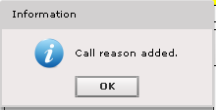  Req-3:  When user presses “Delete”, and if there are existing records with the call reason, a pop-up dialog box like the below will appear (note that header & message may be changed by updating Config XML as stated in Req-1)  Based on selected user language “localization” dialog box message will be Arabic or English  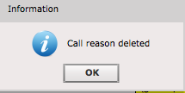  Req-4:  When user presses “Delete” and if there are no more records to delete with the same call reason, a pop-up dialog box like the below will appear (note that header & message may be changed by updating Config XML as stated in Req-1)  Based on selected user language “localization” dialog box message will be Arabic or English  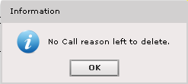
Outstanding  Issues | N.A.

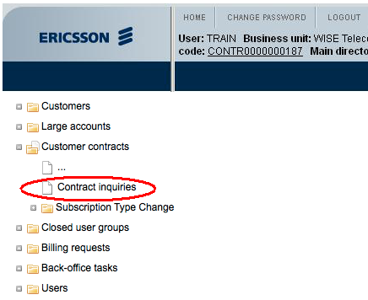
2-a: Contract Inquiries Menu Item
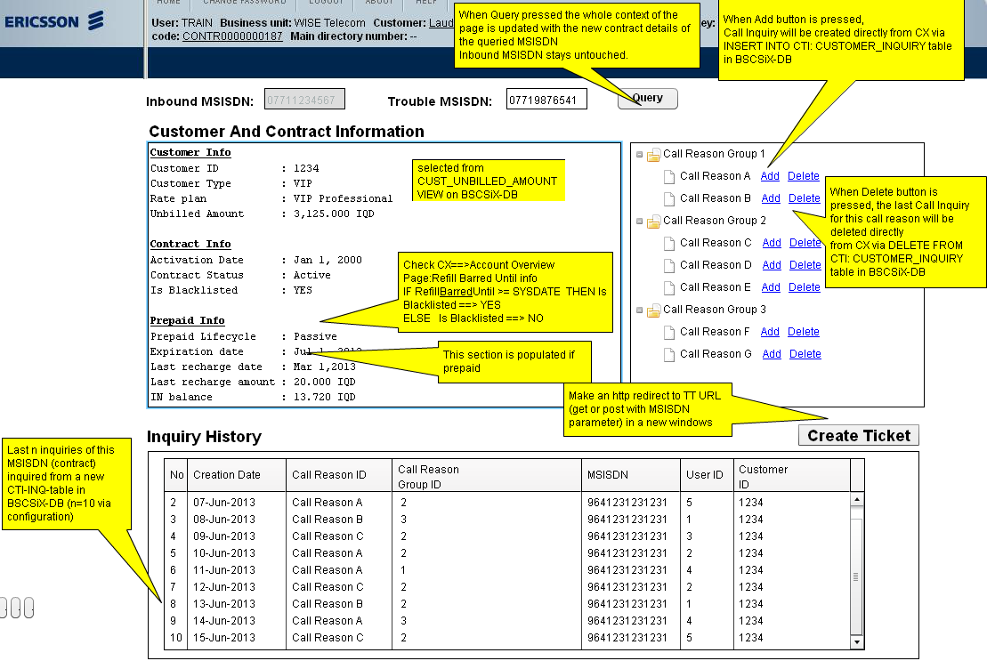
2-b: Contract Inquiries Page

Logical Data Model and Persistence Requirements

Since this SRS is an analysis rather than a technical design document, the aim of this section is NOT a DB design, but to provide;
- The main domains/entities and their relations to be considered during physical DB model design
- Special requirements whether information pertaining to certain domains/entities shall be held historical or not

Main Entities

The following information has been included just to give an example. Please replace this with your own entity information.

DREAM database consists of mainly the below domains/entities;

- Dealer entities; Dealer related Address, Segment, Financial and alike information
- User/Employee entities; Holds user/employee related information. It shall be noted that the same USER entity tables shall be used whether related to an Avea employee or Dealer Employee. Avea employee registered into DREAM is always a USER of DREAM. However, a Dealer Employee registered into DREAM does not necessarily have to be a USER of DREAM, since DREAM also manages Dealer Employees which may be USERs in other systems such as SFA or OM
- Workflow and workflow instances entities; The definition of workflows per different Operation Types and the run-time started workflow instances (tasks) compose this domain
- Batch/Bulk Request entities; Batch Requests submitted into the system and their statuses are managed in this domain
- Access Rights and Positional entities; the definition of position types (job titles) and their hierarchical relation per different Dealer Types and different segments for the same Dealer type, grouping of access rights as responsibility and the default responsibility applicable for a position class is defined in this domain.
- Integration and Events Requests Management entities; DREAM generates events as mentioned in section Error: Reference source not found. This domain is the generic request table where the additional integration adapters asynchronously communicate external systems (such as InfoDealer, OM etc.) using the configurational and runtime information in this domain.
- Document/Template Management related entities.
- Other configuration entities; This domain holds DREAM related configuration data such as specification of characteristics, data types, special validation rules for data types, specification of LOVs and their relations to one another.

Special Persistence Requirements

It shall be mentioned which data domain shall be held historically, frequency of data archival, special data clearance and housekeeping mechanisms, procedures, etc.

Interface & Environment Requirements

External/Public Interfaces

Please define here just the scope of the System Integration of the project.
Publicly accessible system interfaces and or external interfaces, their roles and main functions to be performed by these interfaces are not subject of this section. This will be detailed in different documents (System Architecture Specification or Integration Architecture). Additionally, note that the actual interface specifications will be detailed in its interface specification documents. If the project is quite small and if this SRS shall be addressed as single analysis and design document, then, the integration details can be defined in this section as well.

User/GUI Interfaces

- Specify the actual snapshots/prototype graphical layouts of each user screen. If possible, please illustrate all screens via FlairBuilder tool
- Specify label name, data type, format and validation rules of each field/object of the screens(optional)
- Specify screen logic/behavior and state changes that the end-user will experience (optional)

Screen 1

Screen-1: Snapshot/Prototype

Screen-1: Screen Objects & Validation Rules

Screen-1: Screen Logic

Command Line Interfaces

File-Based Interfaces

Bulk Interfaces

Non-Functional Requirements

Please refer to [1] for detailed description of other non-functional requirements. In case of small projects or if there are very limited number of non-functional requirements, then this section can be used.

Solution Sketch and Preliminary Architecture

This section is optional.
This sections aims to provide a high level summary of the overall design approach considering the limitations and preconditions listed in 9.1. Note that the aim is NOT to provide the design, but provide a helper sketch as an input to design process. The actual detailed design will be documented in more detail within Solution/System Design Specification documents. Note that the actual architecture may change during design phase. In case of small projects where SAS document will not be generated, then this section can be used.

Prerequisites, Assumptions and Restrictions

- Abc
- Abc

Solution Sketch

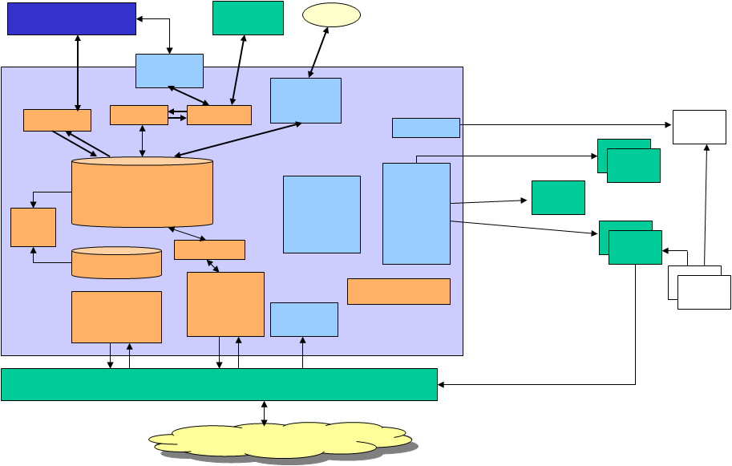
Figure 1: High-Level Architecture Sketch

The above picture describes the preliminary high level architecture inline with the requirements. At this stage detailed module/application level information is not needed and the expected responsibility of each domain is enough. Note that during design phase this architecture may change.
The following sub-sections provide hints and details about the major system domains working harmoniously together as a single system.

Database Domain
….

System/Application Domain-1
….

System/Application Domain-2
….

High-Level Processing Logic

Works, Deliverables and Impacted Areas

This section aims to provide the main deliverables and impacts of the new planned solution as trackable project items so called “JOBS”. Depending on the characteristics of the JOBs ( such as for a new development work), a more detailed design specification document may also be provided upon coming to a mutual agreement on this document.

In order to provide required functionality in the proposed solution and come to a common understanding about the JOBs to be considered by Project Management office, jobs are tagged as <JOB_xxx> in subsequent sections. This section helps especially to Project Managers to prepare a more accurate/detailed Level 2 project plan.

If a job is under CLIENT responsibility, it is tagged as “JOB_CLIENTNAME_xxx”.

Customization Development Works for AS-IS Components

JOB_ID | New Component Name | Job Description
<JOB_001> | [APRMWEB.EAR] | I2i shall provide BEA Web Logic compliant screens and controller logic software module inline with referenced Error: Reference source not found and functionality described in this document
<JOB_002> | [APRMWS.EAR] | I2i shall provide BEA Web Logic compliant back-end services web service software module

New Development Works

JOB_ID | New Component Name | Job Description
<JOB_101> | [APRMWEB.EAR] | I2i shall provide BEA Web Logic compliant screens and controller logic software module inline with referenced Error: Reference source not found and functionality described in this document
<JOB_102> | [APRMWS.EAR] | I2i shall provide BEA Web Logic compliant back-end services web service software module
<JOB_103> | [BackEnd Services] | I2i Shall provide the components related to Back End Service layer as described in section Error: Reference source not found to fulfill the requirements and use cases described in this document  - REQIF  - BACH  - TMF  - WFE  - INT-E  (Plug-Ins for integration interfaces to external applications are out of scope for this iteration)

Integration and Configuration Works

JOB_ID | Related  Component  If ANY | Job Description
<JOB_CLIENT _201> | DSF | Provide integration interfaces and relevant documentation inline with integration strategy in section Error: Reference source not found.
<JOB_CLIENT_202> | InfoDealer | Provide integration interfaces and relevant documentation inline with integration strategy in section Error: Reference source not found.

Database and Migration Works

JOB_ID | Job Description
<JOB_301> | I2i shall deliver DREAM-DB with all required automated scripts to setup the relevant DB including all configuration and baseline setup mentioned in section 10.3
<JOB_302> | I2i shall provide hands-on specialized setup and operational support to migrate Dealers, Client Users and Dealer Users for initial upload via provided batch file upload interfaces.  Once initial migration (data upload) is completed, DREAM configuration (performance parameters, number of threads, external systems integration flags etc.) will be reverted to daily use.
<JOB_303> | Client shall provide the below data set compliant with provided excel based file upload interfaces (as detailed in Error: Reference source not found) for submitting bulk requests;  - Dealer upload  - Dealer User Upload  - Client User Upload (to be detailed during detailed design, since this information may be automatically retrieved from Client LDAP)  At least 3 rehearsals shall be accomplished till cutover.

Operational & Documentation Works

JOB_ID | Job Description
<JOB_401> | I2i will provide for each module the below;  - Unix install/uninstall script  - Module start and stop scripts
<JOB_402> | I2i will provide a detailed Shipment Note for each shipment provided highlighting the changes, fixes introduced with relevant shipment whether be partial or full shipment

Other Works

JOB_ID | Job Description
<JOB_CLIENT_501> | All hardware procurement inline with section Error: Reference source not found is under Client responsibility
<JOB_CLIENT_502> | Client shall provide remote access to i2i.

Appendix

Document Control

Superseded Documents
- N/A

Change Control & Distribution
Owner | [OWNER NAME]
Reviewer
Approved By
Distribution
File Name | 0000.doc

Version History
Version | Change Descriptions | Author | Date
1.0.0 | Initial Version | [Author Name] | 01/Jan/2014

Approvals
This document requires the following approvals:

Name | Title | Date | Signature | Version

